* [Format the names of members](https://pgexercises.com/questions/string/concat.html)

select surname || ', ' || firstname as name from cd.members;

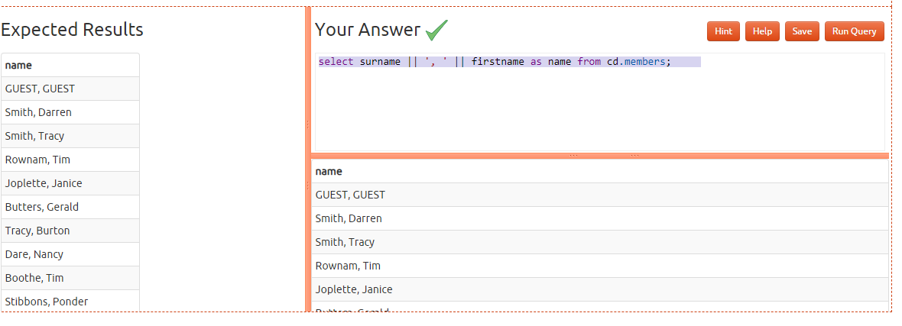

* [Find facilities by a name prefix](https://pgexercises.com/questions/string/like.html)

select * from cd.facilities where name like 'Tennis%';

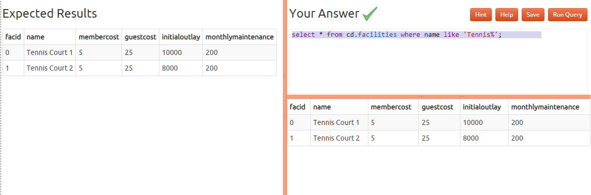

* [Perform a case-insensitive search](https://pgexercises.com/questions/string/case.html)

select * from cd.facilities where upper(name) like 'TENNIS%'; 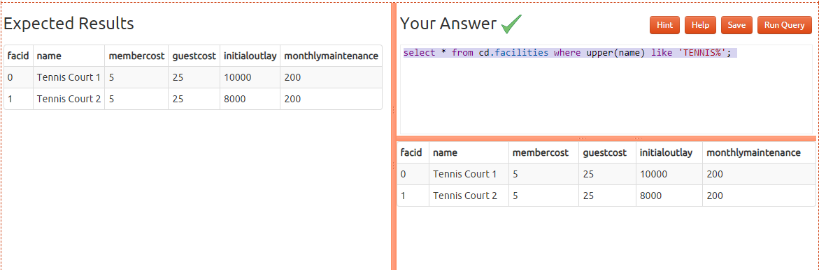

* [Find telephone numbers with parentheses](https://pgexercises.com/questions/string/reg.html)

select memid, telephone from cd.members where telephone ~ '[()]';

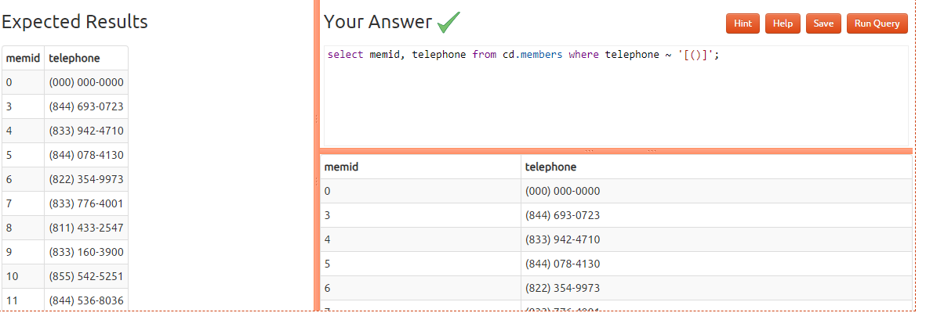

* [Pad zip codes with leading zeroes](https://pgexercises.com/questions/string/pad.html)

select lpad(cast(zipcode as char(5)),5,'0') zip from cd.members order by zip;

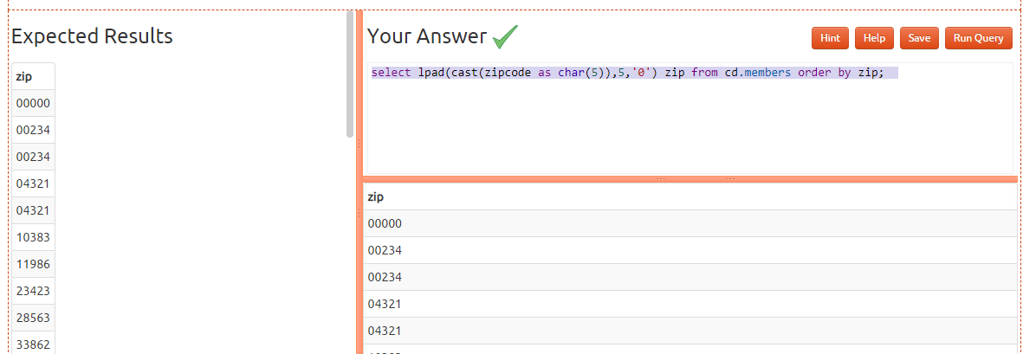

* [Count the number of members whose surname starts with each letter of the alphabet](https://pgexercises.com/questions/string/substr.html)

select substr (surname,1,1) as letter, count(*) as from cd.members group by letter order by letter

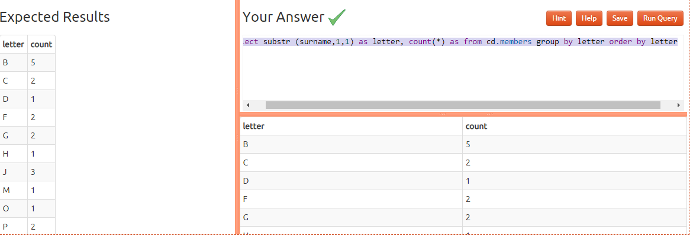

* [Clean up telephone numbers](https://pgexercises.com/questions/string/translate.html)

select memid, translate(telephone, '-() ', '') as telephone from cd.members order by memid;

